

Systel Technical Education Society’s

SYSTEL INSTITUTE OF MANAGEMENT

AND RESEARCH DHULE

AICTE approve
d,
NAAC Accredited

A PROJECT
REPORT
ON

Government schemes finder

FOR

Bachelor of Computer Application(B.C.A.)

SUBMITTED BY

Bhavesh Dinesh Kale

PRN NO : 2023015400278671

GUIDED BY

Prof . Saeed S. Ansari

K.B.C. NORTH MAHARASHTRA UNIVERSITY JALGAON

(202
5
-
202
6
)

Systel Technical Education Society’s
SYSTEL INSTITUTE OF MANAGEMENT
AND RESEARCH DHULE
AICTE Approved , NAAC Accredited



CERTIFICATE

This is to certify that Mr ‘Bhavesh Dinesh Kale’ student of Bachelor of Computer Application (BCA) has satisfactorily completed his project work in subject “Government schemes finder” during the academic year 2025-2026. He has been carried out under my guidance and to the best of my knowledge and belief has not been submitted by elsewhere before.

(Project Guide) (Director)

Prof. Saeed S. Ansari | Prof. Dr. H. M. Patil
External Examiner | External Examiner

ACKNOWLEDGEMENT

It is with great pleasure & effort that I am able to present this project report. I have tried my best to make it complete in all report. I would like to take opportunity to give my sincere thanks to those people who help me directly or indirectly during completion of this project.
I wish to express my deep sense of gratitude & sincere regards to website without whose agreement I can’t step ahead for this project.
I am specially thankful to Project Guide Prof. Saeed S. Ansari & Director Prof. Dr. H. M. Patil for their valuable guidance & making me avail with all possible resources for this Project.
Next I would like to mention me special thanks to all Faculty members of Systel Institute Of Management & Research, Dhule & all my friends who have contributed me much to complete this project. At last but not least I would like to convey my regards to my Family members specially my parents whose emotional support is always with me during this project.

Bhavesh Dinesh Kale

CERTIFICATE

This is certify that Mr Bhavesh Dinesh Kale student of Bachelor of Computer Application (BCA) for Systel Institute of Management and Research, Dhule under K.B.C. North Maharashtra University, Jalgaon. He has completed their project “Government schemes finder” in our organization. Their project work satisfy meet all requirements for computerization of our system.
We wish them for their bright future.

Authorized Signature

Index

Content | Page No.
1. Introduction
- Introduction of Project
- Need of System
- Objectives
2. Proposed System
- Proposed System
- Feasibility Study
- Hardware and Software Specifications
- Introduction to Software
- Software Requirement Specification (SRS)

3.Data Analysis
- Data Flow Diagram
- Entity Relationship Diagram
- UML Diagram

4. System Design
- Data Dictionary
- Modularization details
- Input Output Screen Design

5.Testing Procedures
• Testing Procedure

6.Conclusion and Suggestions
- Scope for the Future Enhancement
- Conclusion
- Suggestions

7. Bibliography and References
- Books
- Websites

Introduction

1. Introduction

1.1 Introduction of Project

The Government Scheme Eligibility Finder is a web-based application developed to bridge the gap between Indian citizens and the government welfare schemes they are entitled to. Millions of eligible citizens are unaware of or unable to access government schemes due to lack of information and complex bureaucratic processes. This system provides a single, unified digital platform where users can discover both Central Government and Maharashtra State Government schemes, and instantly check their eligibility based on their personal profile.
The system is developed using Python (Flask) as the backend framework, SQLite as the database, and HTML, CSS, and JavaScript for the frontend. The application empowers citizens by giving them instant access to 44+ government schemes spanning categories such as healthcare, agriculture, housing, financial inclusion, education, and social welfare.
Key highlights of the system include:
- 44+ government schemes across Central and Maharashtra State governments
- Instant eligibility checking engine based on user profile data
- User dashboard with personal eligibility history
- Admin panel for comprehensive scheme and user management
- Responsive design that works on mobile, tablet, and desktop devices
- Secure authentication with SHA-256 password hashing
- Smart eligibility engine that dynamically asks for missing profile data

This system eliminates manual searching through multiple government websites and provides a single point of access for scheme discovery and eligibility verification. It helps travel agencies and government offices reduce paperwork and improves citizen awareness of available benefits.

1.2 Need of System

India has hundreds of Central and State government welfare schemes designed to uplift various sections of society. However, a large majority of eligible citizens either do not know about these schemes or cannot determine whether they qualify. This creates a significant gap between policy implementation and actual benefit delivery.
Traditional methods of scheme discovery involve visiting government offices, searching through multiple disconnected websites, or relying on intermediaries who may provide incomplete or incorrect information. This results in delays, missed benefits, and unnecessary hardship for citizens.
The following challenges highlight the critical need for this system:
- Citizens are unaware of the large number of schemes available to them across Central and State governments
- Manual eligibility checking requires visits to multiple government offices and collecting several documents
- There is no centralized platform to compare and check eligibility for multiple schemes simultaneously
- Lack of digital infrastructure forces citizens to rely on word-of-mouth or intermediaries for scheme information
- Administrative burden on government offices due to manual processing and repeated inquiries
- Eligible beneficiaries from rural areas and economically weaker sections are the most affected due to digital divide
- Existing portals provide only information without any personalized eligibility checking feature
A web-based Government Scheme Eligibility Finder directly addresses all these challenges by creating a centralized, automated, and user-friendly platform accessible from any internet-connected device.

1.3 Objectives

The main objectives of the Government Scheme Eligibility Finder project are:
- To design and develop a user-friendly web application for discovering and checking eligibility for government schemes
- To provide a centralized database of 44+ Central and Maharashtra State government schemes with detailed information including benefits, eligibility criteria, and required documents
- To implement an intelligent eligibility checking engine that compares user profile data against scheme-specific criteria using logical operators
- To allow users to register with their personal profile data and get personalized scheme recommendations instantly
- To maintain a history of all eligibility checks done by each user on their personal dashboard
- To develop a comprehensive admin panel for managing users, schemes, eligibility criteria, and monitoring user activity
- To build a secure system with SHA-256 password hashing and role-based access control
- To create a responsive design accessible on mobile phones, tablets, and desktop computers
- To reduce manual effort and improve citizen awareness about government welfare schemes
- To provide a scalable platform that can be enhanced with additional schemes and features in the future

Proposed System

2. Proposed System

2.1 Proposed System

The proposed system is a full-stack web application built with Python Flask that automates the process of government scheme discovery and eligibility checking. The system replaces the scattered, manual, and office-visit-dependent process with a centralized digital platform.
The system operates on a two-tier architecture: a web-based frontend that users interact with through a browser, and a backend server that processes eligibility logic and manages the database. The application is designed to be deployed on a local server (127.0.0.1:5000) and can be scaled to production hosting.
The proposed system provides the following core functionalities:
- User Registration: Citizens register once with their complete profile including age, income, caste, gender, state, and occupation
- Scheme Discovery: Users can browse all 44+ schemes, filtered by government (Central / Maharashtra) and category
- Instant Eligibility Check: The eligibility engine compares user profile against scheme criteria and returns Eligible or Not Eligible with reasons
- Eligibility History: Users can view all their past eligibility checks on a personal dashboard
- Admin Dashboard: Administrators can manage users, schemes, eligibility criteria, and view activity logs
- Dynamic Questioning: If user profile is incomplete for a specific scheme, the system dynamically asks for the additional required information

2.2 Feasibility Study

Technical Feasibility
The system uses Python 3.8+, Flask, SQLite, HTML5, CSS3, and JavaScript - all widely supported, stable, and production-ready technologies. Flask is a lightweight but powerful web framework ideal for this project's scope. SQLite provides a zero-configuration database perfect for this application. The technology stack requires no paid licenses and runs on standard hardware.
Economic Feasibility
All development tools and frameworks are open-source and free. Python, Flask, and SQLite have no licensing costs. The system can run on any standard computer or low-cost cloud hosting. Development cost is limited to developer time only, making the project highly economically feasible.
Operational Feasibility
The system is designed with simplicity in mind. Citizens with basic internet skills can register, browse schemes, and check eligibility without any training. The admin panel provides a straightforward interface for government officials to manage scheme data. The responsive design ensures accessibility from any device.
Schedule Feasibility
The project was completed within the academic year 2025-2026 timeline. The modular architecture allowed parallel development of different components, keeping the project on schedule.

2.3 Hardware and Software Specifications

Hardware Requirements
Component | Specification
Processor | Intel Core i3 or higher (1.6 GHz+)
RAM | Minimum 4 GB (8 GB recommended)
Storage | Minimum 10 GB free disk space
Display | 1024x768 resolution or higher
Internet | Stable broadband connection (1 Mbps+)
Input Devices | Standard keyboard and mouse

Software Requirements
Software | Specification
Operating System | Windows 10/11, Ubuntu 20.04+, or macOS 11+
Programming Language | Python 3.8 or higher
Web Framework | Flask 3.x (pip install flask)
Database | SQLite 3 (built into Python)
Frontend | HTML5, CSS3, JavaScript (ES6+)
Web Browser | Google Chrome, Mozilla Firefox, Microsoft Edge
Code Editor | Visual Studio Code (VS Code)
Package Manager | pip (Python Package Installer)
Version Control | Git (optional, for version management)

2.4 Introduction to Software

The Government Scheme Eligibility Finder is built using a carefully selected modern technology stack that balances simplicity, performance, and scalability. Each technology plays a specific role:
Python 3.8+
Python is the core programming language used for this project. It is known for its readable syntax and a rich ecosystem of libraries. Python handles all server-side logic including request processing, eligibility calculations, and database operations.
Flask (Web Framework)
Flask is a lightweight Python web framework used to build the backend of the application. It handles URL routing, session management, template rendering using Jinja2, and form data processing. Flask's decorator-based route system makes the code clean and easy to maintain.
SQLite (Database)
SQLite is used as the relational database system. It is a file-based database that requires zero configuration and is ideal for single-server deployments. The database stores users, schemes, eligibility criteria, eligibility history, and user activity logs.
HTML5, CSS3, JavaScript (Frontend)
HTML5 structures the web pages, CSS3 handles the visual design with a clean and modern aesthetic using custom variables, gradients, and responsive grid layouts. JavaScript provides interactivity such as tab switching, form validation, and dynamic content updates.
Jinja2 (Template Engine)
Jinja2 is Flask's built-in templating engine. It allows embedding Python logic directly into HTML templates for dynamic content rendering, loops, conditionals, and template inheritance through a base layout file.
SHA-256 (Security)
Passwords are stored securely using SHA-256 cryptographic hashing via Python's built-in hashlib library. This ensures passwords are never stored in plain text in the database.

2.5 Software Requirement Specification (SRS)

Functional Requirements
- FR-01: Users shall be able to register with username, password, full name, age, income, caste, gender, state, occupation, mobile, and email
- FR-02: Users shall be able to login and logout securely with session management
- FR-03: The system shall display all government schemes with filtering by state (Central/Maharashtra) and category
- FR-04: Users shall be able to view detailed information for each scheme including description, benefits, and required documents
- FR-05: The system shall check eligibility for any scheme based on the user's profile data
- FR-06: If user profile data is incomplete for a scheme check, the system shall dynamically request the missing information
- FR-07: Eligibility results shall show Eligible or Not Eligible with detailed reasons
- FR-08: All eligibility check results shall be saved to the user's history
- FR-09: Admin shall be able to add, edit, and delete schemes and eligibility criteria
- FR-10: Admin shall be able to view, edit, delete, and promote users
- FR-11: Admin shall be able to view complete eligibility history and user activity logs

Non-Functional Requirements
- NFR-01: The system shall respond to user requests within 2 seconds under normal load
- NFR-02: All passwords shall be stored using SHA-256 hashing
- NFR-03: The system shall be accessible from any modern web browser
- NFR-04: The application shall have a responsive design working on screens from 320px to 1920px wide
- NFR-05: The system shall maintain user session security and prevent unauthorized access to protected routes
- NFR-06: The codebase shall be modular and maintainable for future enhancements

Data Analysis

3. Data Analysis

3.1 Data Flow Diagram (DFD)

The Data Flow Diagram illustrates how data moves through the Government Scheme Eligibility Finder system. It shows the interactions between Citizens (Users), Administrators, the Application Server, and the SQLite Database.

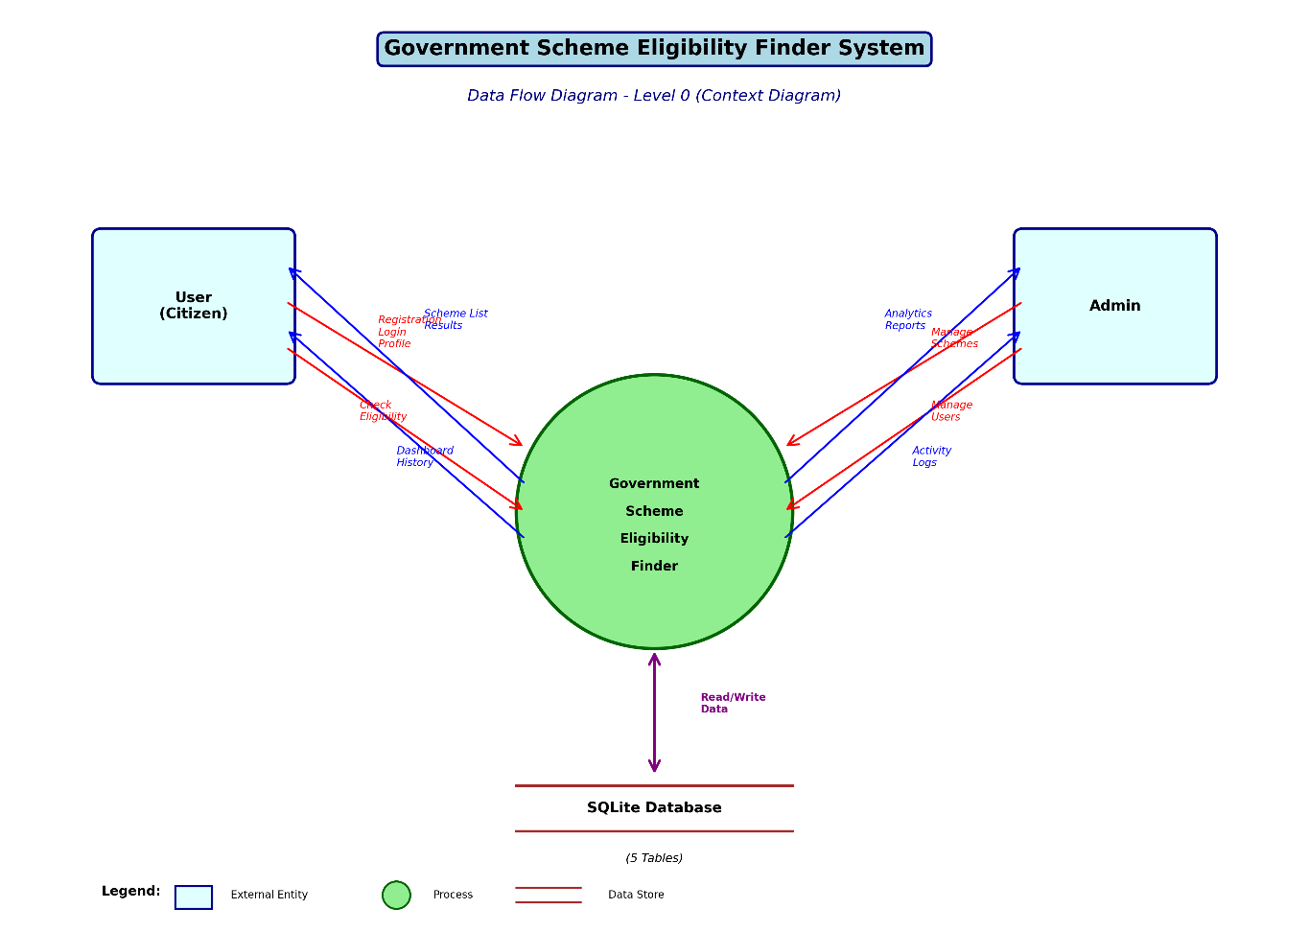

DFD Level 0 – Context Diagram
At the highest level, the system receives inputs from two external entities: the Citizen/User and the Administrator. It processes these inputs and provides outputs back to both entities while communicating with the database.
Entity | Input to System | Output from System
Citizen/User | Registration data, Login credentials, Eligibility check requests, Scheme browse | Scheme listings, Eligibility results (Eligible/Not Eligible), Dashboard history, E-Ticket
Administrator | Admin login credentials, New scheme data, Scheme edits/deletions, User management actions | Dashboard stats, User lists, Scheme lists, Activity logs, Eligibility history
SQLite Database | Stored user profiles, scheme data, eligibility criteria, history | Retrieved data for display, comparison, and reporting

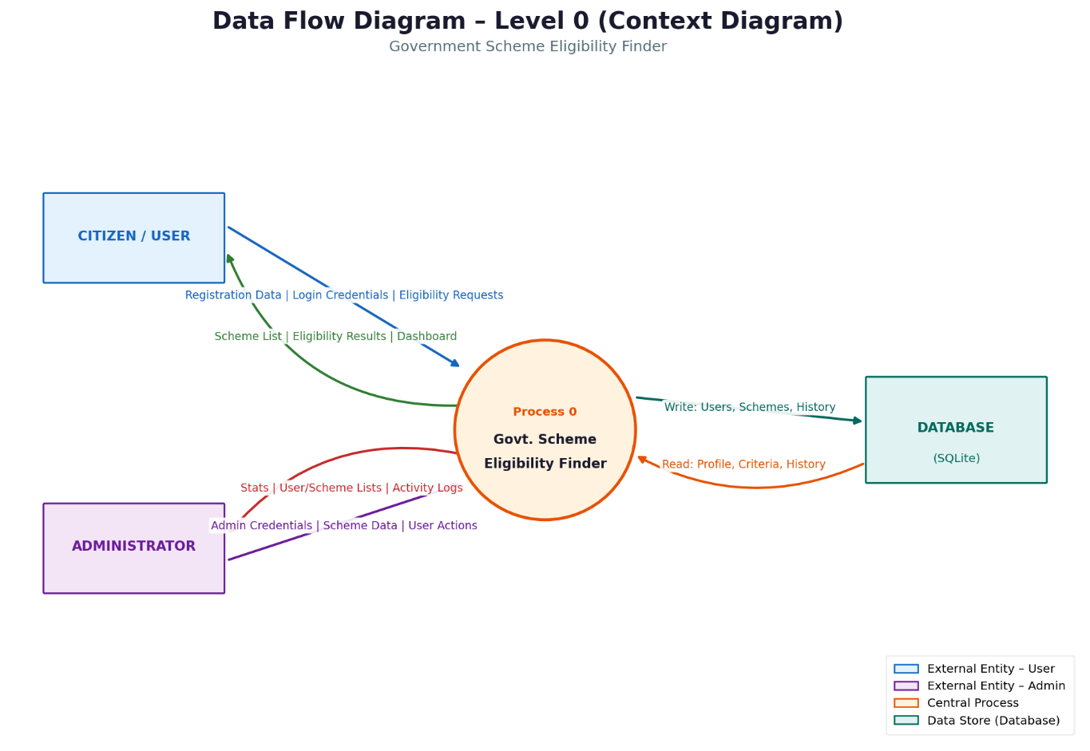

DFD Level 1 – Process Decomposition
At Level 1, the system decomposes into the following major processes
:
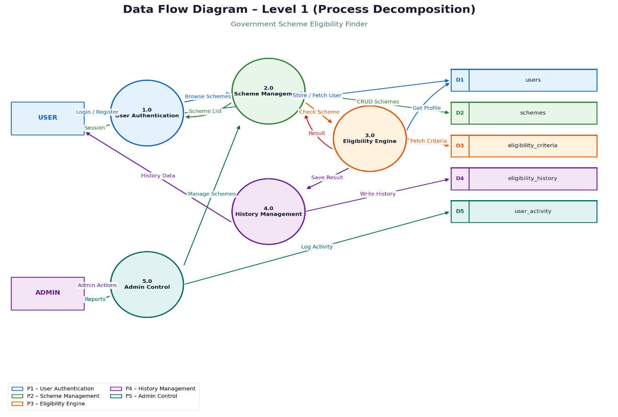
- Process 1.0 – User Authentication: Handles registration, login validation, and session management
- Process 2.0 – Scheme Management: Displays schemes with filtering by state and category; handles admin CRUD operations
- Process 3.0 – Eligibility Engine: Fetches user profile, retrieves scheme criteria, applies operators (eq, lte, gte, lt, gt, in), returns result with reasons
- Process 4.0 – History Management: Records all eligibility checks with timestamp, scheme, result, and reason
- Process 5.0 – Admin Control Panel: Manages users, schemes, eligibility criteria, and views activity logs

3.2 Entity Relationship Diagram (ER Diagram)

Entity/Table | Key Attributes | Relationships
users | id (PK), username, password, full_name, age, income, caste, gender, state, occupation, mobile, email, role | 1:N with eligibility_history; 1:N with user_activity
schemes | id (PK), name, description, benefits, documents, category, state | 1:N with eligibility_criteria; 1:N with eligibility_history
eligibility_criteria | id (PK), scheme_id (FK), field, label, operator, value | N:1 with schemes
eligibility_history | id (PK), user_id (FK), scheme_id (FK), result, reason, checked_at | N:1 with users; N:1 with schemes
user_activity | id (PK), user_id (FK), action, timestamp | N:1 with users
The ER Diagram shows the database entities and their relationships in the Government Scheme Eligibility Finder system. The database consists of 5 main tables:

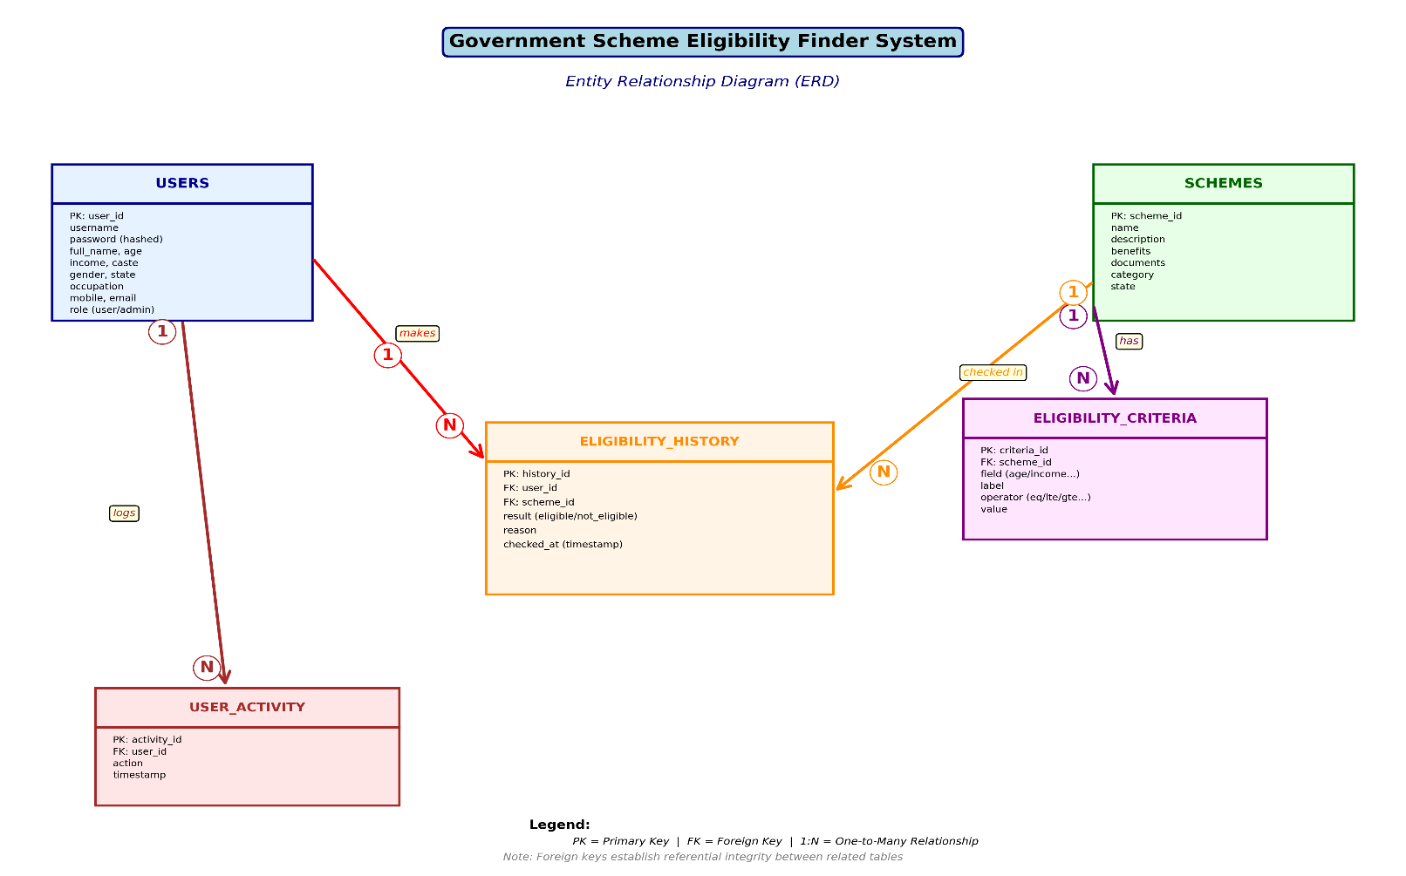

Relationships Summary:
- One User can have Many Eligibility History records (one-to-many)
- One Scheme can have Many Eligibility Criteria (one-to-many)
- One Scheme can appear in Many Eligibility History records (one-to-many)
- One User can generate Many User Activity log entries (one-to-many)

3.3 UML Use Case Diagram

The UML Use Case Diagram describes the interactions between system actors (User and Administrator) and the system's functional use cases.
Actors
- User (Citizen): Unregistered visitors and registered citizens who use the system to discover and check scheme eligibility
- Administrator: Authorized system manager who maintains schemes, users, and monitors activity
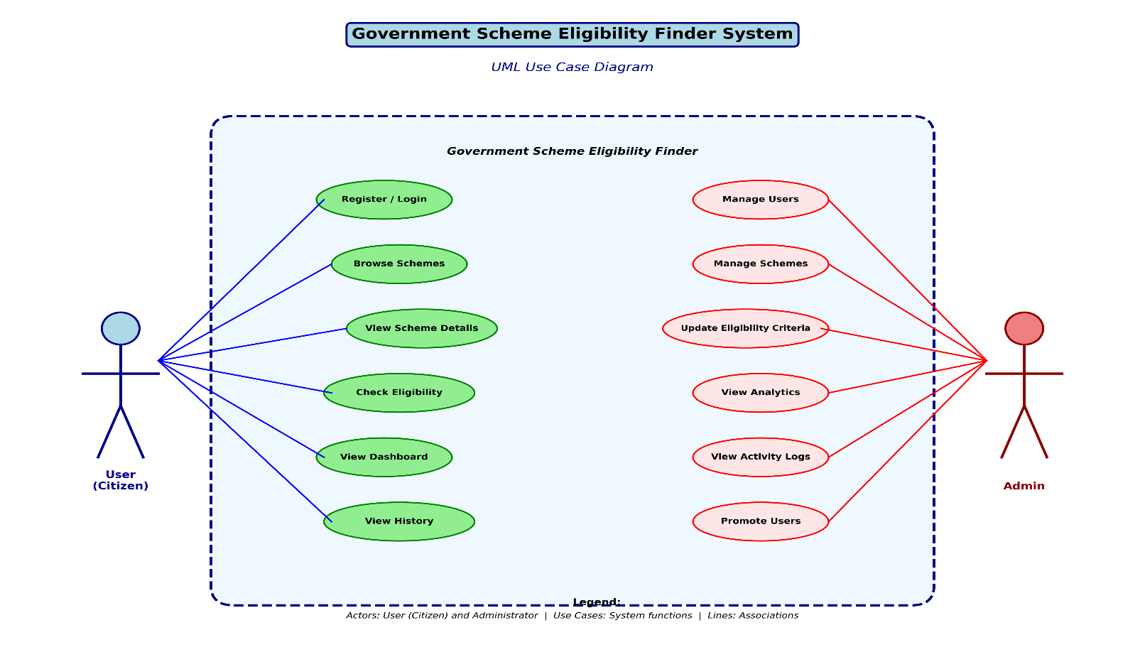
User Use Cases
Use Case | Description
UC-01: Register Account | New user provides personal profile data to create an account
UC-02: Login / Logout | User authenticates with username and password; ends session on logout
UC-03: Browse Schemes | User views all available schemes with filtering by government and category
UC-04: View Scheme Details | User clicks on a scheme to see full description, benefits, and documents required
UC-05: Check Eligibility | User requests eligibility check for a specific scheme; system compares profile to criteria
UC-06: View Eligibility Result | User sees Eligible or Not Eligible result with reasons
UC-07: View Dashboard | User views their personal dashboard with eligibility check history

Administrator Use Cases
Use Case | Description
UC-08: Admin Login | Admin authenticates with special credentials to access admin panel
UC-09: View Dashboard Stats | Admin sees total users, schemes, and eligibility checks at a glance
UC-10: Manage Users | Admin views, edits, deletes, or promotes users to admin role
UC-11: Manage Schemes | Admin adds new schemes, edits scheme details, or deletes schemes
UC-12: Manage Eligibility Criteria | Admin sets and updates eligibility criteria for each scheme
UC-13: View Eligibility History | Admin views all eligibility checks made by all users
UC-14: View User Activity | Admin monitors login/logout and activity timestamps for all users

System Design

4. System Design

4.1 Data Dictionary

4.1.1 Users Table
Field Name | Size | Data Type | Constraint | Description
id | 11 | INTEGER | Primary Key, Auto | Unique user identifier
username | 50 | TEXT | UNIQUE, NOT NULL | Login username
password | 255 | TEXT | NOT NULL | SHA-256 hashed password
full_name | 100 | TEXT | NULL | User's complete name
age | 3 | INTEGER | NULL | User's age in years
income | - | REAL | NULL | Annual income (float)
caste | 50 | TEXT | NULL | Caste category
gender | 20 | TEXT | NULL | Gender of user
state | 50 | TEXT | NULL | Home state
occupation | 50 | TEXT | NULL | Occupation type
mobile | 15 | TEXT | NULL | Mobile number
email | 100 | TEXT | NULL | Email address
role | 20 | TEXT | DEFAULT 'user' | Role: user or admin

4.1.2 Schemes Table
Field Name | Size | Data Type | Constraint | Description
id | 11 | INTEGER | Primary Key, Auto | Unique scheme ID
name | 200 | TEXT | NOT NULL | Scheme name
description | - | TEXT | NULL | Detailed description
benefits | - | TEXT | NULL | Benefits provided
documents | - | TEXT | NULL | Required documents
category | 100 | TEXT | NULL | Scheme category
state | 50 | TEXT | NULL | Central / Maharashtra

4.1.3 Eligibility Criteria Table
Field Name | Size | Data Type | Constraint | Description
id | 11 | INTEGER | Primary Key, Auto | Unique criteria ID
scheme_id | 11 | INTEGER | Foreign Key | References schemes.id
field | 50 | TEXT | NOT NULL | Profile field to check (age, income, etc.)
label | 100 | TEXT | NULL | Human-readable label
operator | 10 | TEXT | NOT NULL | Comparison operator (eq, lte, gte, lt, gt, in)
value | 100 | TEXT | NOT NULL | Threshold value to compare against

4.1.4 Eligibility History Table
Field Name | Size | Data Type | Constraint | Description
id | 11 | INTEGER | Primary Key, Auto | Unique record ID
user_id | 11 | INTEGER | Foreign Key | References users.id
scheme_id | 11 | INTEGER | Foreign Key | References schemes.id
result | 20 | TEXT | NOT NULL | Eligible or Not Eligible
reason | - | TEXT | NULL | Detailed reason for result
checked_at | - | TEXT | NOT NULL | ISO timestamp of check

4.1.5 User Activity Table
Field Name | Size | Data Type | Constraint | Description
id | 11 | INTEGER | Primary Key, Auto | Unique activity ID
user_id | 11 | INTEGER | Foreign Key | References users.id
action | 50 | TEXT | NOT NULL | Action performed (login, logout, etc.)
timestamp | - | TEXT | NOT NULL | ISO timestamp of action

4.2 Modularization Details

The Government Scheme Eligibility Finder system is organized into well-defined modules, each handling a specific area of functionality. This modular approach improves maintainability, enables independent testing, and supports future enhancements.

Module 1: Authentication Module
- Files: app.py (routes: /signup, /login, /logout), login.html, signup.html
- Functionality: User registration with profile data, secure login with SHA-256 password hashing, session management, role-based access control (user vs admin), activity logging on login/logout

Module 2: Home Module
- Files: app.py (route: /), home.html
- Functionality: Landing page displaying scheme categories for both Central and Maharashtra governments, hero section with system statistics, navigation to signup/login or schemes based on session state

Module 3: Scheme Discovery Module
- Files: app.py (routes: /schemes, /scheme/<id>), schemes.html, scheme_detail.html
- Functionality: Display all 44+ schemes with filtering by state and category, detailed scheme view with description, benefits, required documents, and a button to check eligibility

Module 4: Eligibility Engine Module
- Files: app.py (route: /check_eligibility/<scheme_id>), check_eligibility.html, eligibility_result.html
- Functionality: Retrieve scheme eligibility criteria, compare user profile data using operators (eq, lte, gte, lt, gt, in), handle missing profile data dynamically, save result to history, display eligible/not eligible with reasons

Module 5: User Dashboard Module
- Files: app.py (route: /dashboard), dashboard.html
- Functionality: Display user's complete profile, show full eligibility check history with scheme names, results, and timestamps

Module 6: Admin Panel Module
- Files: app.py (routes: /admin, /admin/users, /admin/schemes, /admin/history), admin/ templates
- Functionality: Admin dashboard with statistics (total users, schemes, eligibility checks), user management (view, edit, delete, promote), scheme management (add, edit, delete), eligibility criteria management, activity log viewing

Module 7: Database Module
- Files: database.py
- Functionality: SQLite database initialization, table schema creation, seed data insertion (44+ schemes with full details and eligibility criteria), database connection management using Flask's application context

4.3 Input / Output Screen Design

4.3.1 Home Page
The home page presents the system with a hero section, scheme category tabs for Central and Maharashtra governments, and clear calls to action. The hero shows statistics: 45+ Schemes, 2 Governments, 10+ Categories.

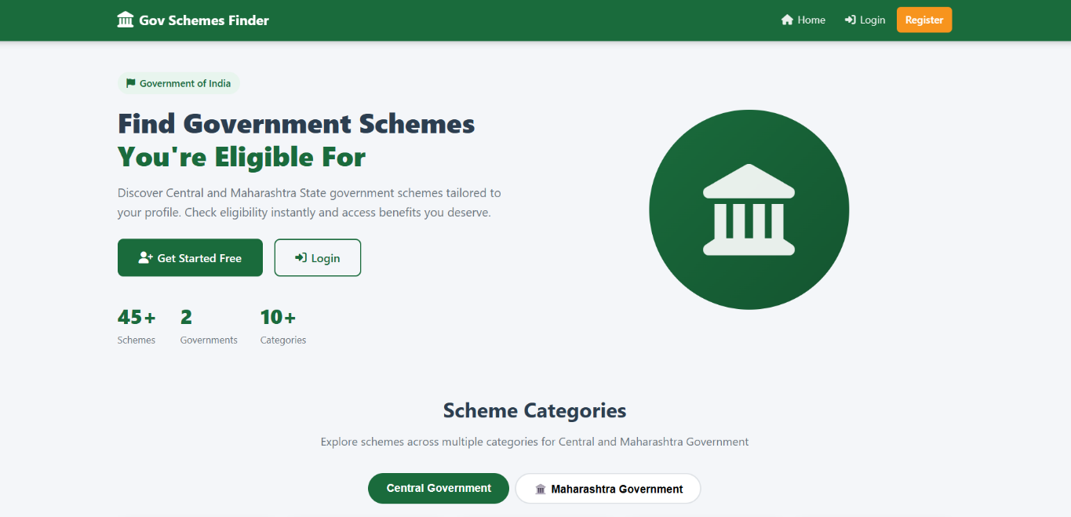
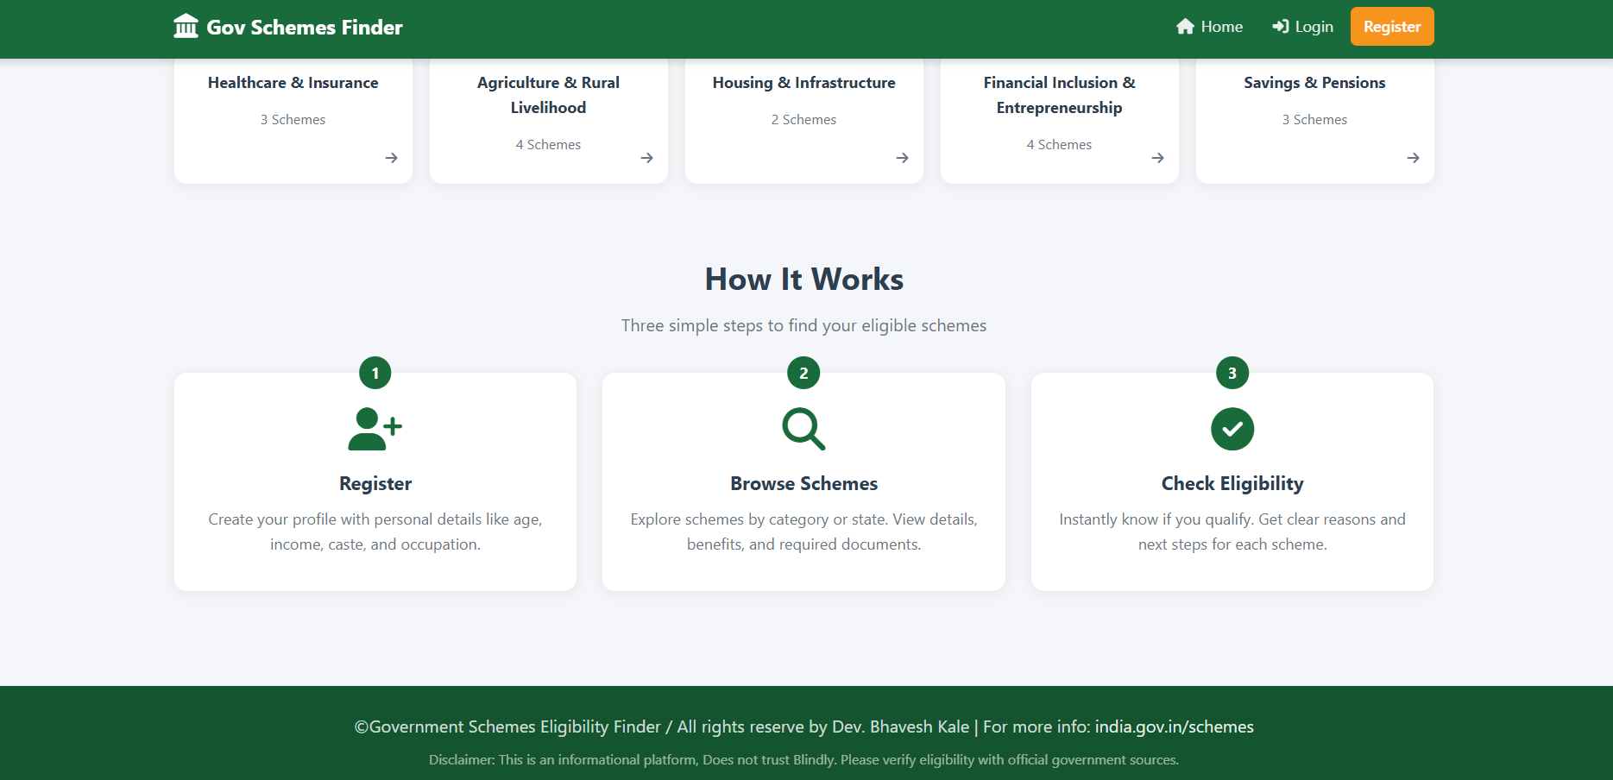

4.3.2 User Registration Page
The registration form collects 12 fields: username, password, full name, age, annual income, caste, gender, state, occupation, mobile number, and email. Input validation ensures data integrity before submission.
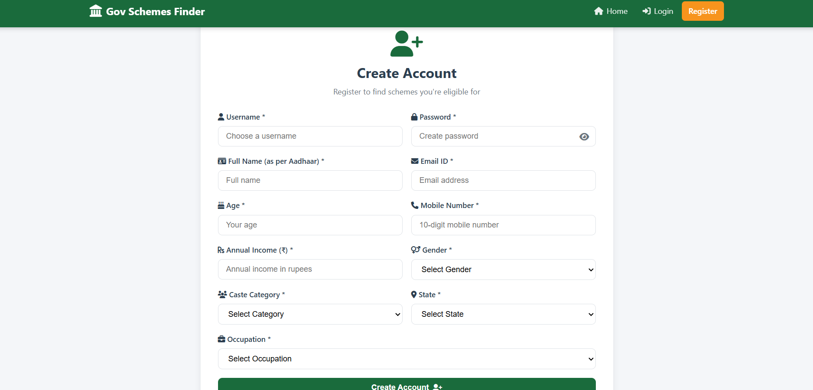

4.3.3 Login Page
Clean login interface with username and password fields. Incorrect credentials trigger a flash error message. Successful admin login redirects to admin dashboard; user login redirects to user dashboard.
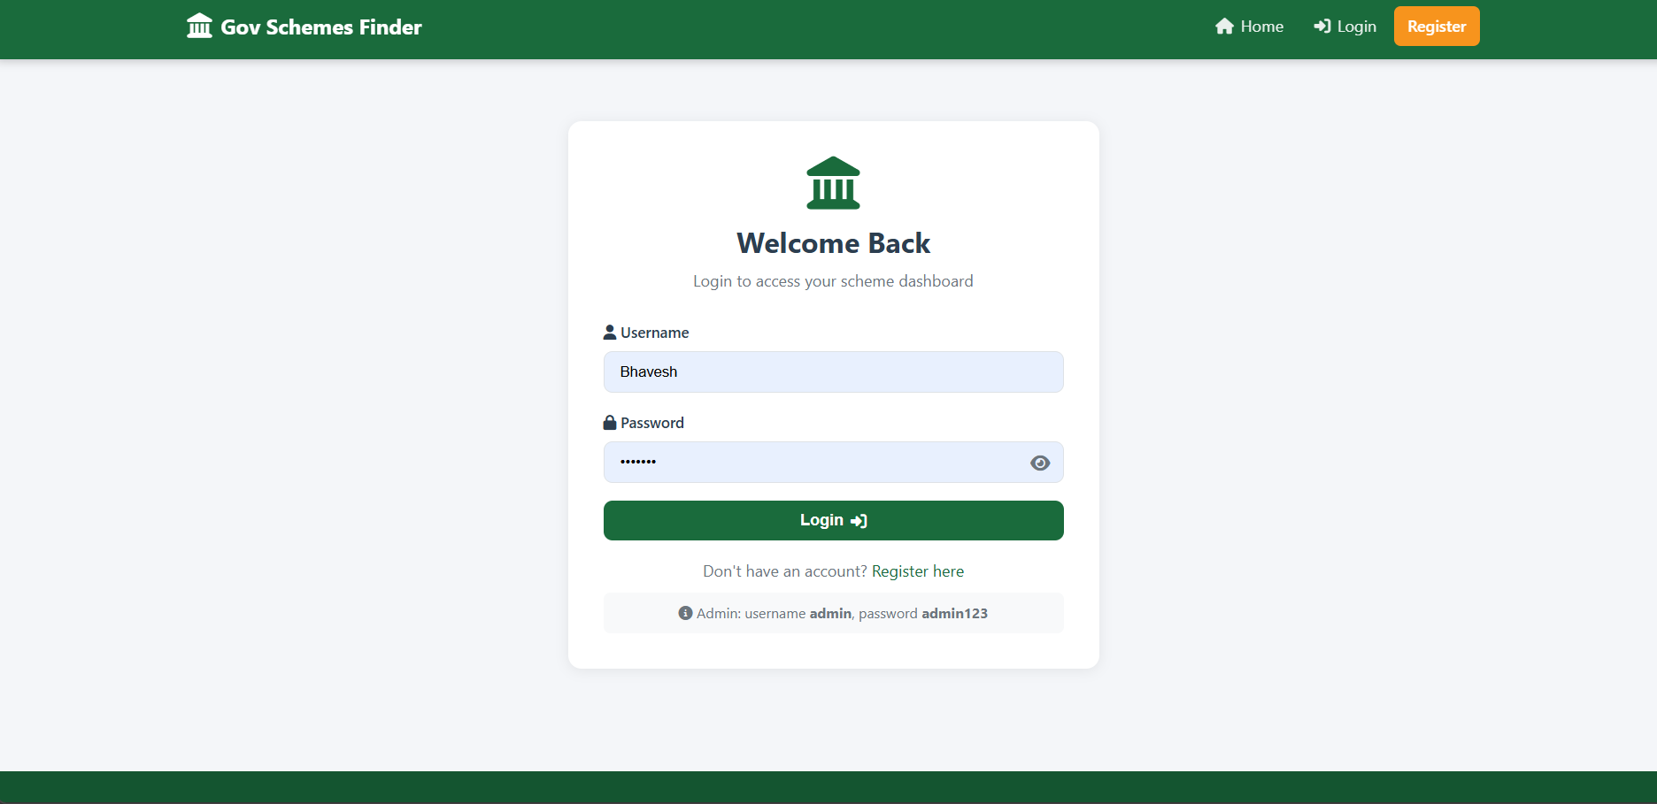

4.3.4 Schemes Listing Page
Displays all schemes in a card grid layout. Users can filter by state (Central/Maharashtra) using URL query parameters. Each card shows scheme name, category, state badge, and a 'View Details' button.

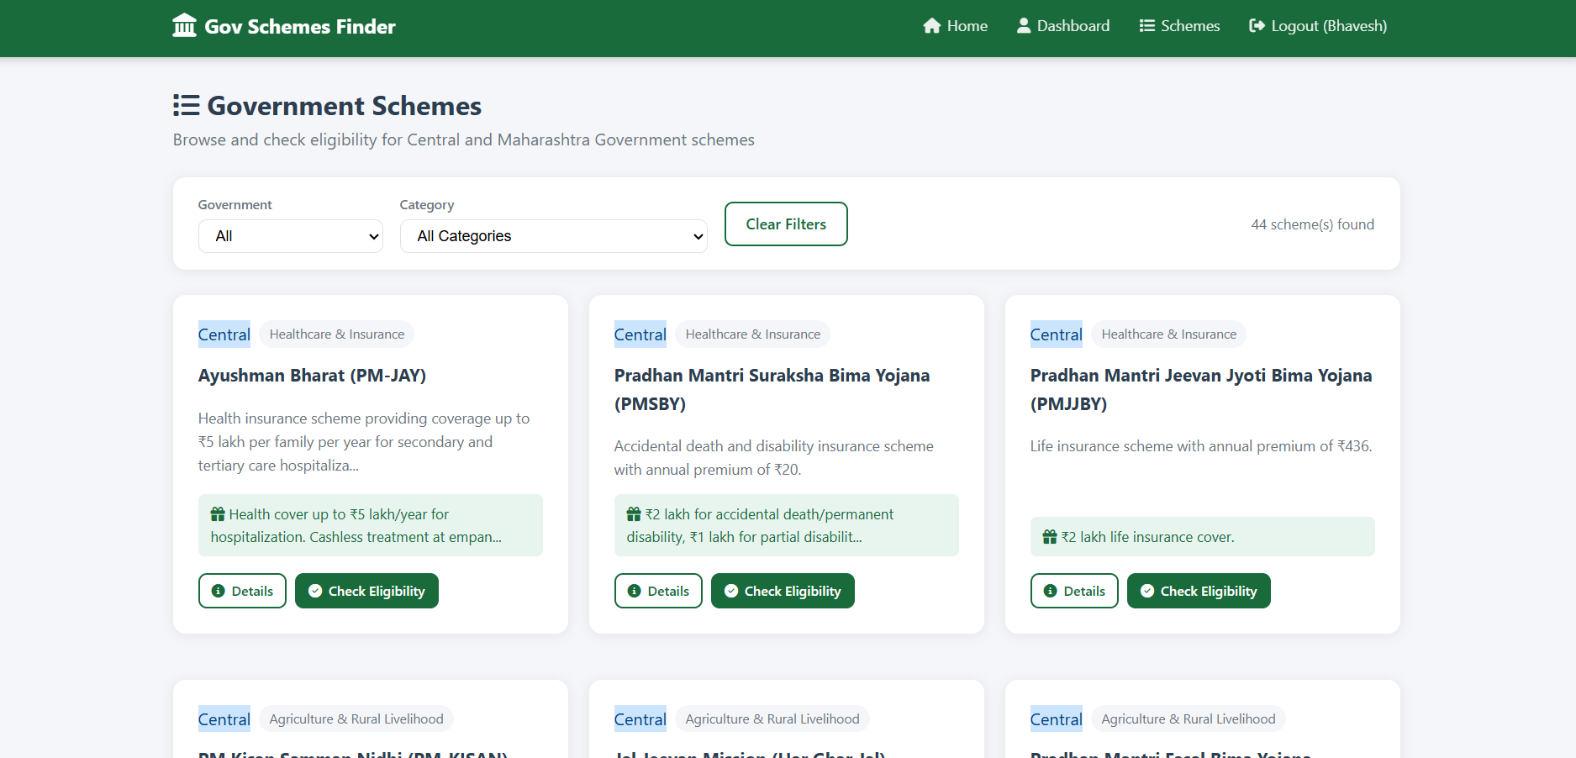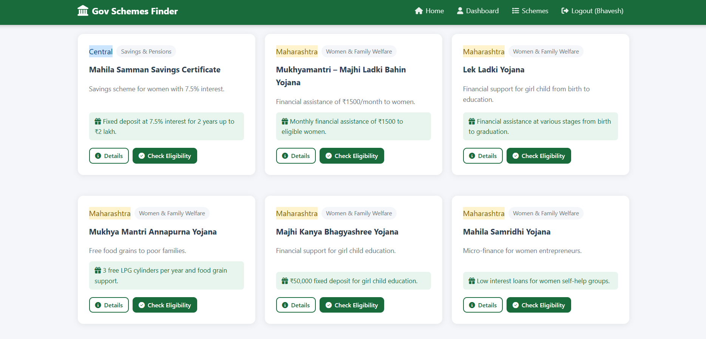

4.3.5 Scheme Detail Page

Example : PM Kisan Samman Nidhi (PM-KISAN)
Full detail page showing scheme name, description, benefits (formatted as a list), required documents, state/category badges, and a prominent 'Check My Eligibility' button. 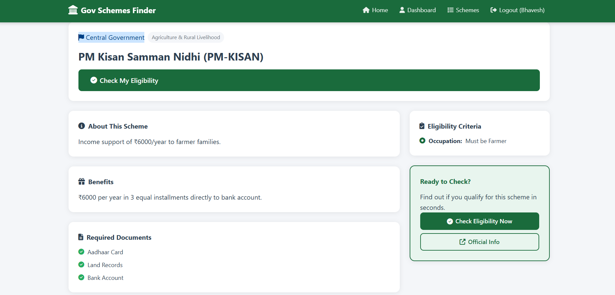

4.3.6 Eligibility Check Page

Example : PM Kisan Samman Nidhi (PM-KISAN)
If user profile is complete, eligibility is checked automatically. If additional data is needed, a dynamic form appears asking for the specific missing information required by the scheme's criteria. 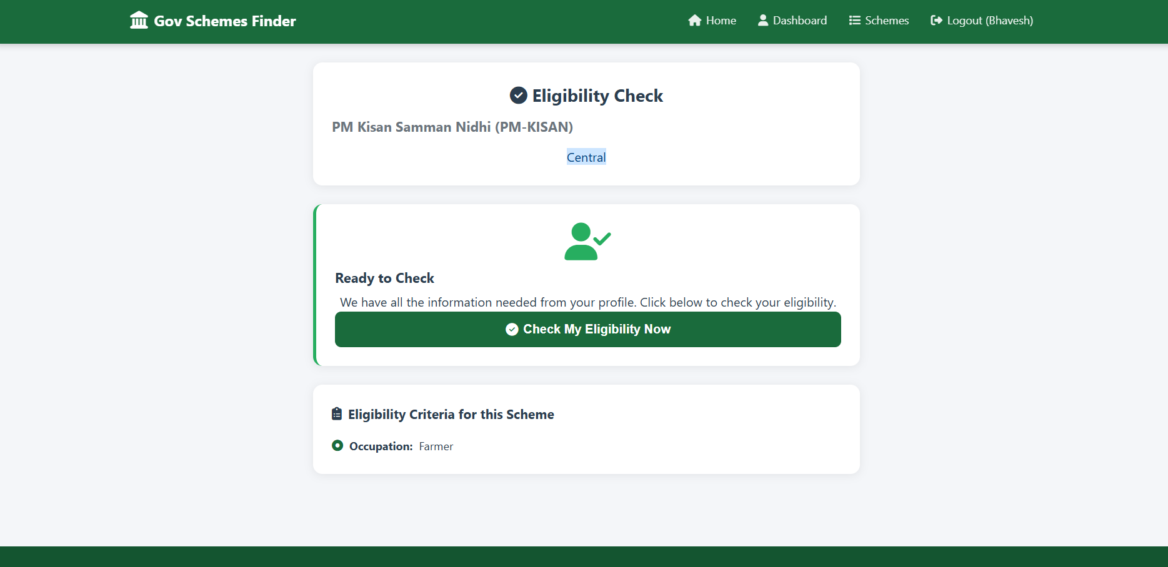

4.3.7 Eligibility Result Page

Example : PM Kisan Samman Nidhi (PM-KISAN)
Displays the result prominently: green 'ELIGIBLE' badge or red 'NOT ELIGIBLE' badge. Shows detailed reasons for each criterion - which passed and which failed. Options to check other schemes or return to dashboard. 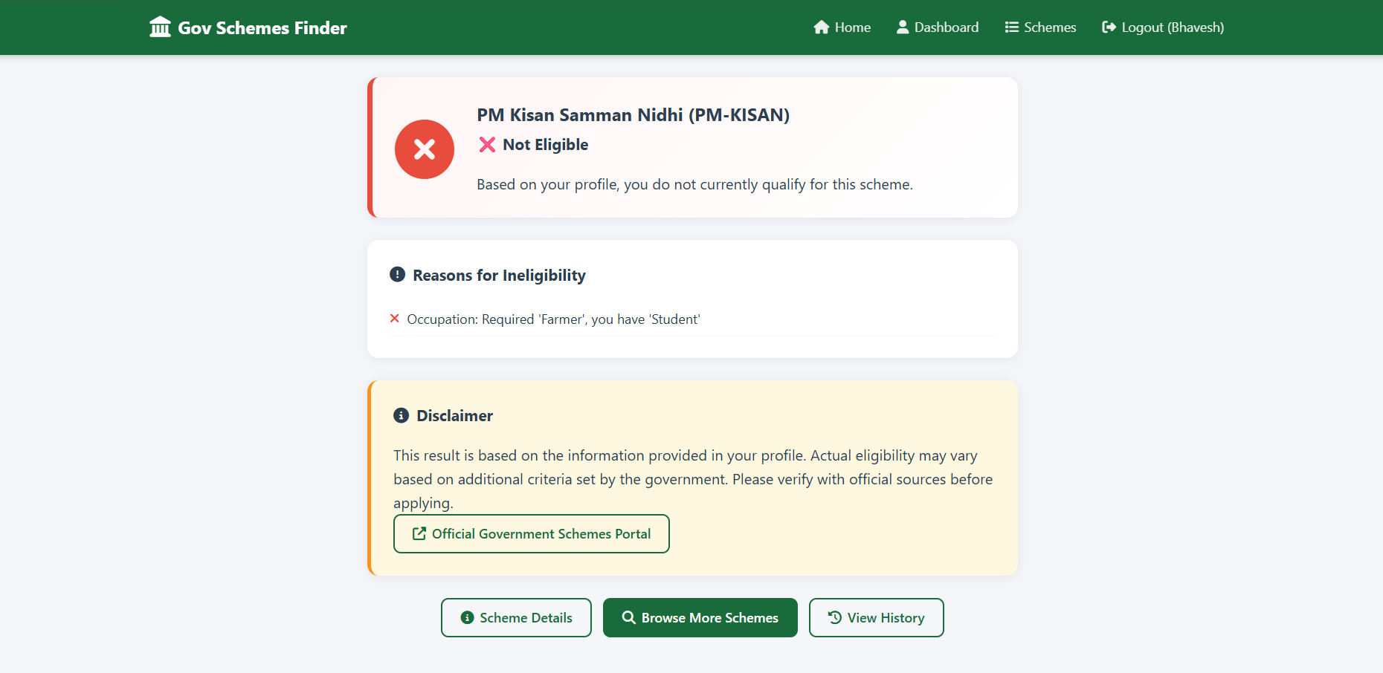

4.3.8 User Dashboard
Shows user's profile information and complete eligibility check history in a table format with scheme name, category, government (state), result badge, and timestamp of each check. 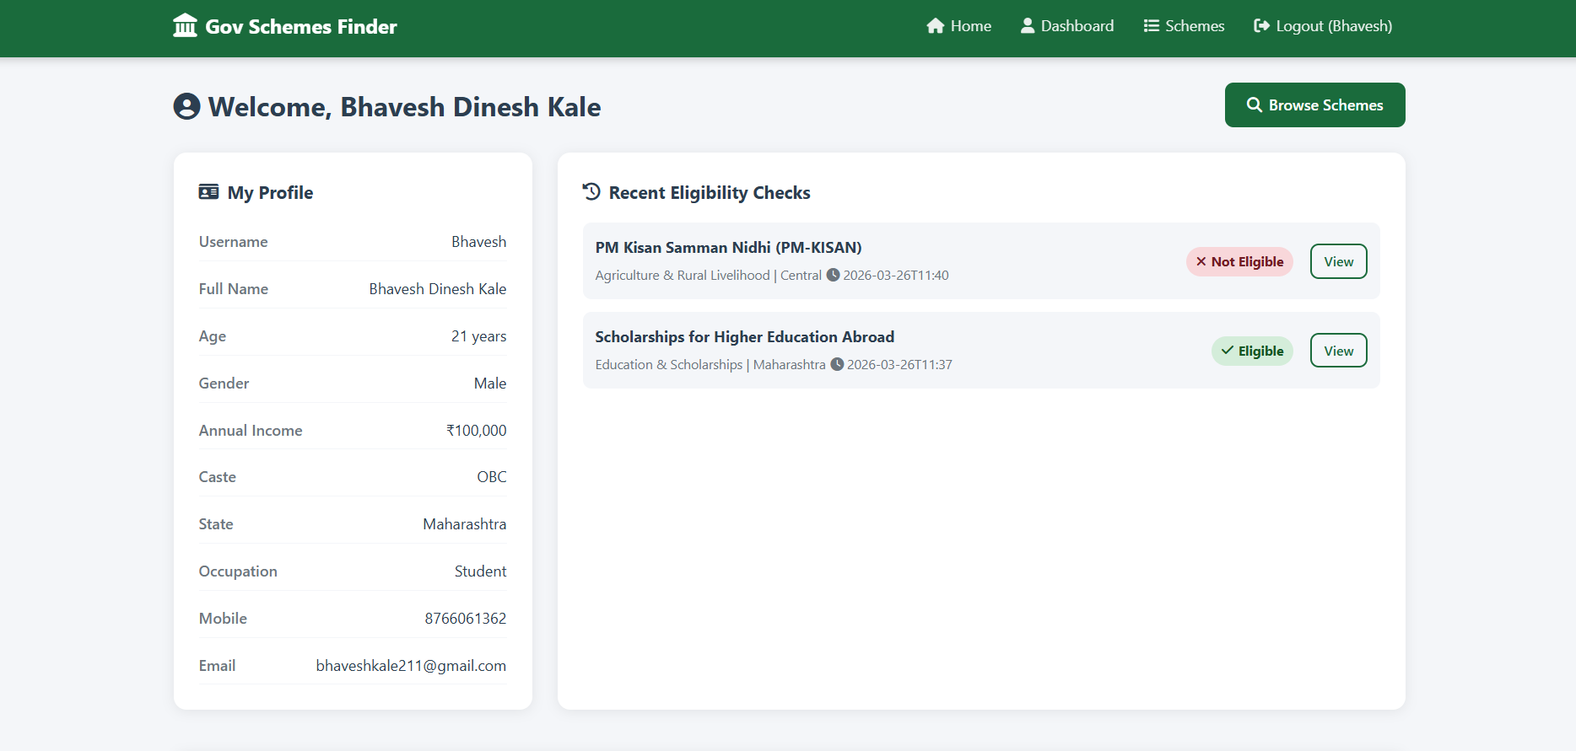

4.3.9 Admin Dashboard
Statistics overview showing total registered users, total schemes, and total eligibility checks. Navigation sidebar links to Manage Users, Manage Schemes, View History, and Logout. 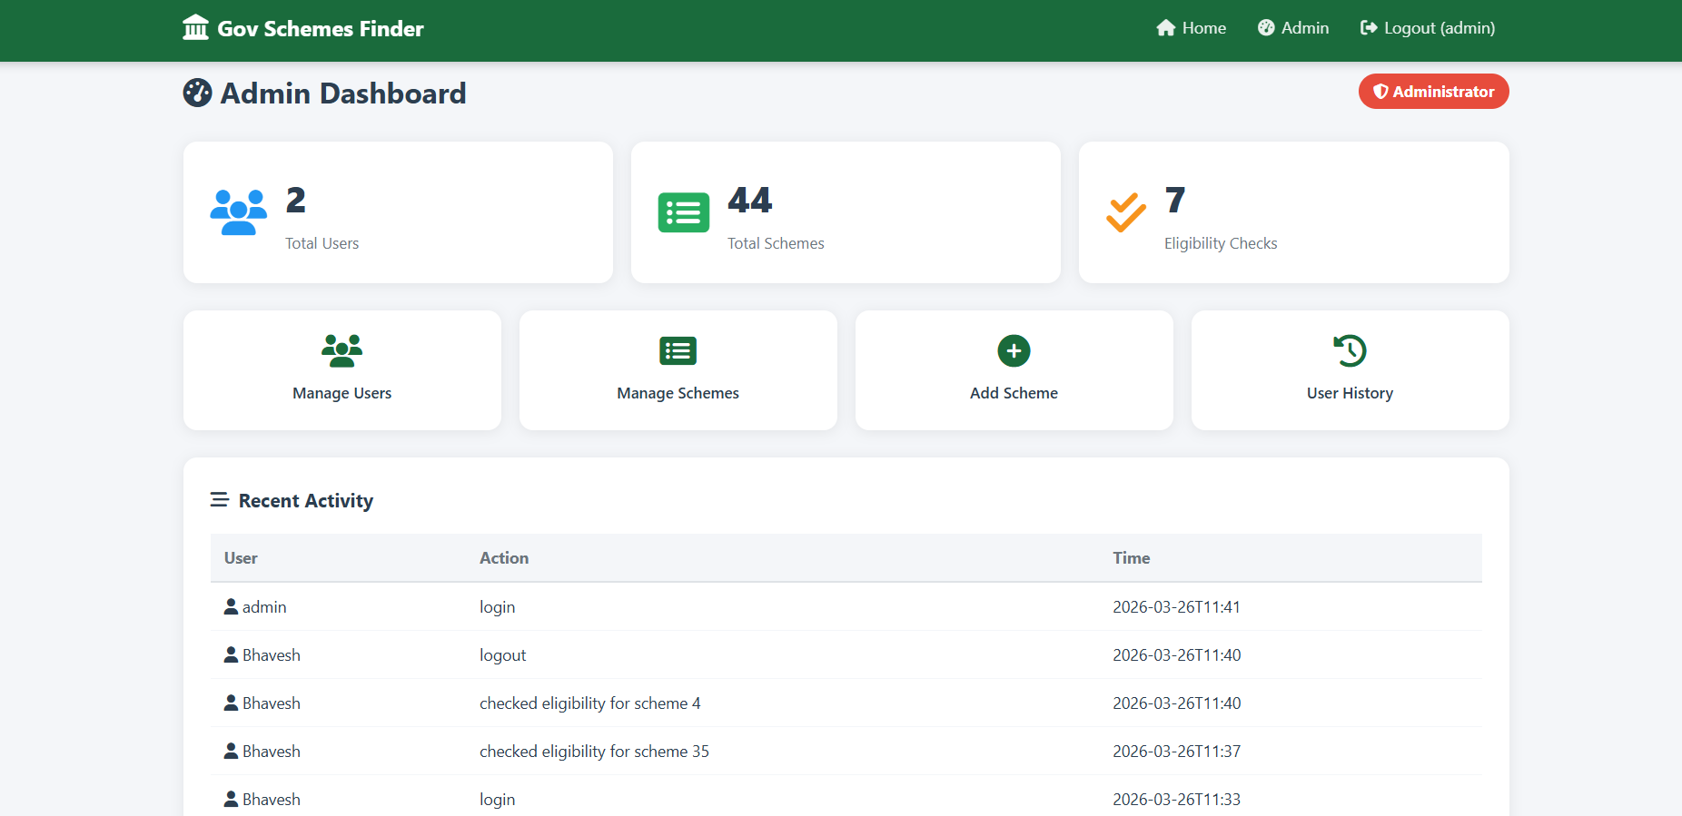

4.3.10 Admin Scheme Management
Table listing all schemes with ID, name, category, state, and action buttons (Edit/Delete). An 'Add New Scheme' form at the top allows adding new schemes with all fields. Editing opens a pre-filled form for the selected scheme. 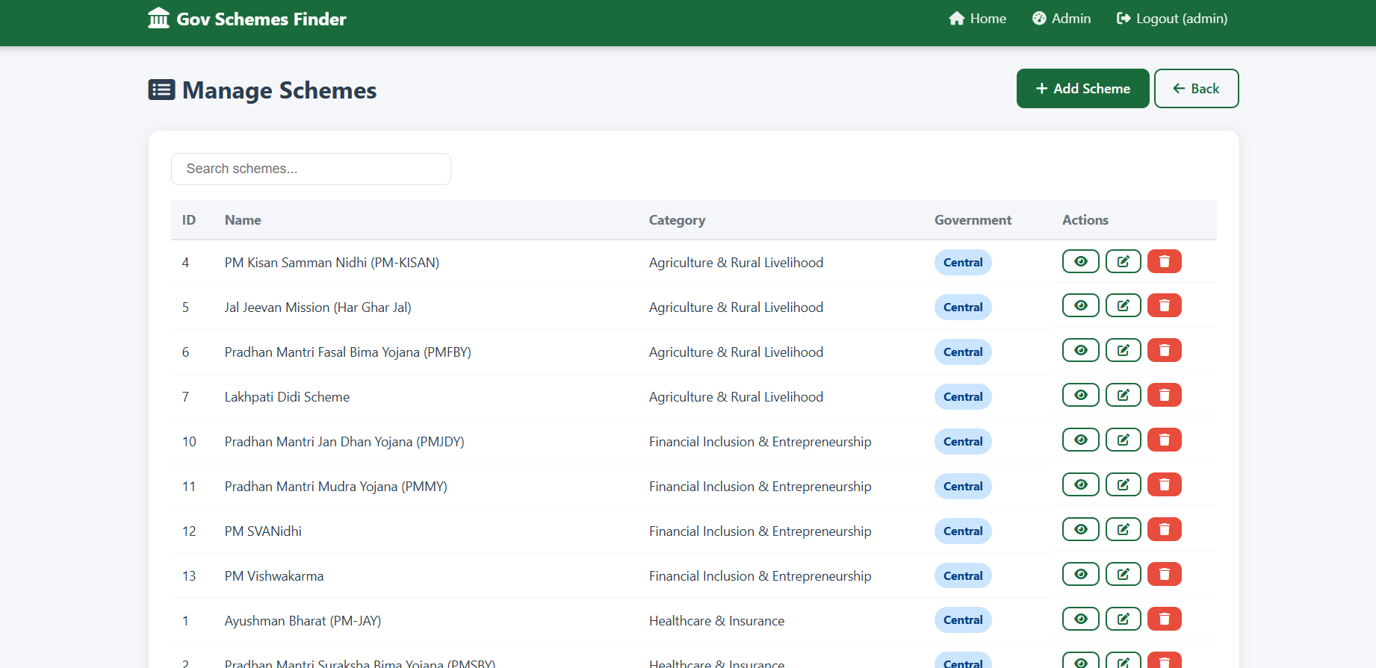

4.3.11 Admin Eligibility Criteria Management
Per-scheme criteria management showing existing criteria (field, label, operator, value) with delete option. Form to add new criteria specifying field name, display label, comparison operator, and threshold value.
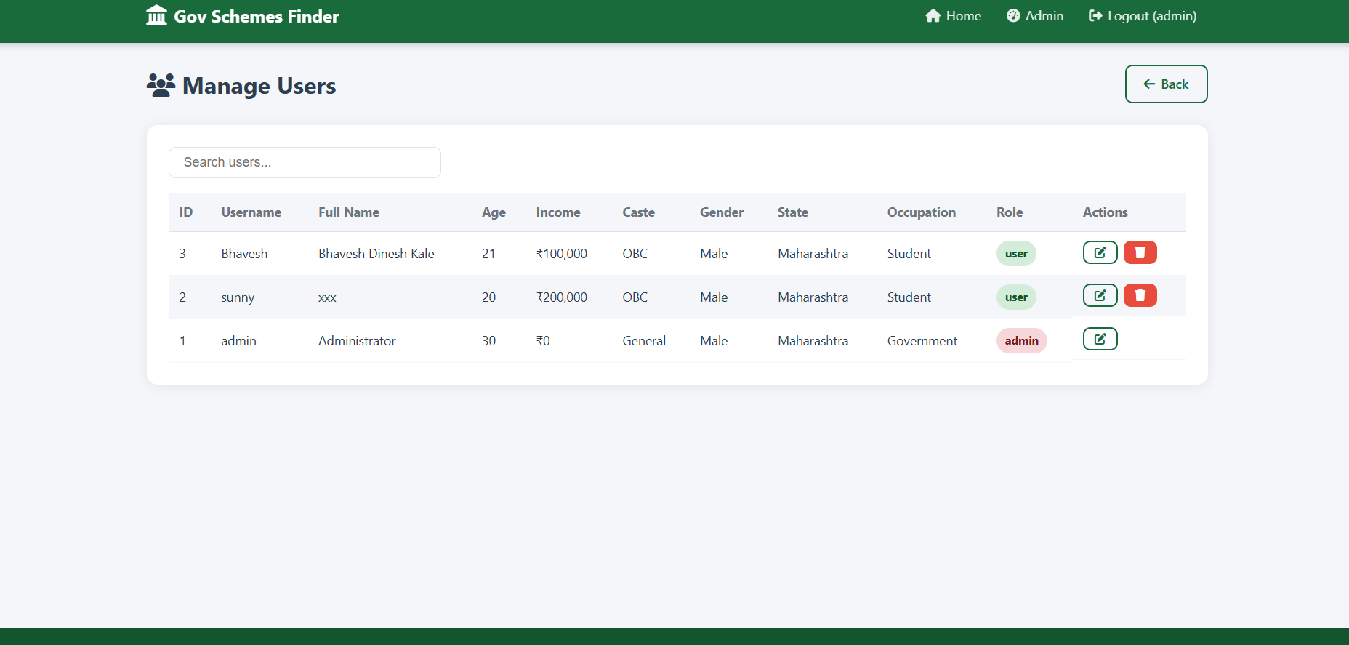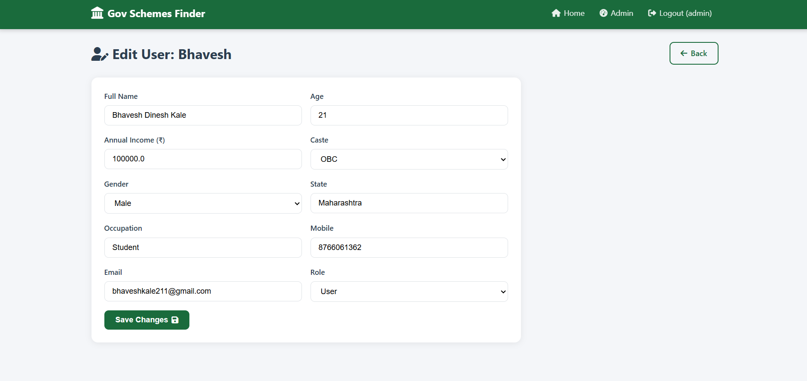

Testing Procudures

5. Testing Procedures

5.1 Eligibility Engine Logic
The eligibility engine is one of the most critical components of the system. It compares user profile fields against scheme-specific criteria using logical operators. The following operators are supported:
Operator | Meaning | Example
eq | Equal to | gender = Female (scheme is only for women)
lte | Less than or equal | age <= 60 (maximum age limit)
gte | Greater than or equal | age >= 18 (minimum age requirement)
lt | Strictly less than | income < 200000 (below poverty criteria)
gt | Strictly greater than | age > 65 (senior citizen schemes)
in | One of a set | caste in SC,ST,OBC (reserved category schemes)

5.2 Scheme Distribution Overview

The system contains 44 government schemes distributed across 11 categories from two governments. The following chart shows the distribution:
Scheme Count by Category – Visual Overview
Category | Government | No. of Schemes
Healthcare & Insurance | Central Government | 3
Agriculture & Rural Livelihood | Central Government | 4
Housing & Infrastructure | Central Government | 2
Financial Inclusion & Entrepreneurship | Central Government | 4
Savings & Pensions | Central Government | 3
Women & Family Welfare | Maharashtra State | 6
Agriculture & Farmers | Maharashtra State | 6
Youth & Employment | Maharashtra State | 4
Education & Scholarships | Maharashtra State | 4
Senior Citizens & Social Assistance | Maharashtra State | 4
Housing & Infrastructure | Maharashtra State | 4

Summary: Central Government - 16 Schemes | Maharashtra State - 28 Schemes | Total - 44 Schemes

5.3 Test Cases

The following test cases were designed and executed to verify all major functions of the system:
TC ID | Module | Test Input / Action | Expected Result | Status
TC-01 | User Registration | Enter valid name, username, age=25, income=50000, and all required fields | New user account created successfully and redirected to login | PASS
TC-02 | User Login | Enter correct username and password | User logged in successfully and redirected to dashboard | PASS
TC-03 | Invalid Login | Enter wrong password for existing user | Error flash message shown: Invalid credentials | PASS
TC-04 | Scheme Browse | Click on Schemes page as logged-in user | All 44 schemes displayed in card grid | PASS
TC-05 | Scheme Filter | Filter schemes by state=Maharashtra | Only Maharashtra schemes displayed (28 schemes) | PASS
TC-06 | Scheme Detail | Click View Details on Ayushman Bharat | Full scheme details shown with benefits and documents | PASS
TC-07 | Eligibility Check – Eligible | Check eligibility for PM-KISAN with valid farmer profile (income<200000, occupation=farmer) | Result: ELIGIBLE with all criteria passed shown in green | PASS
TC-08 | Eligibility Check – Not Eligible | Check Sukanya Samriddhi with male user | Result: NOT ELIGIBLE with reason: gender does not match (requires female) | PASS
TC-09 | Dynamic Field Request | Check eligibility for a scheme when profile field is missing | Dynamic form appears asking for the specific missing information | PASS
TC-10 | History Saving | Check eligibility for multiple schemes | All checks saved and visible in user dashboard history | PASS
TC-11 | Admin Login | Login with username=admin, password=admin123 | Admin dashboard opened with statistics overview | PASS
TC-12 | Admin Add Scheme | Fill new scheme form and submit with all fields | New scheme added and appears in scheme listing | PASS
TC-13 | Admin Edit Scheme | Click Edit on an existing scheme and update name | Updated scheme details saved successfully | PASS
TC-14 | Admin Delete Scheme | Click Delete on a scheme | Scheme removed from database and listing | PASS
TC-15 | Admin User Management | View users list in admin panel | All registered users shown with full details | PASS
TC-16 | Session Security | Access /dashboard URL without logging in | Redirected to login page with flash warning | PASS
TC-17 | Admin Access Control | Access /admin URL as a regular user | Access denied, redirected to login page | PASS
TC-18 | Logout | Click logout button | Session cleared, redirected to home page | PASS

Conclusion & suggestions

6. Conclusion and Suggestions

6.1 Scope for Future Enhancement

The current version of the Government Scheme Eligibility Finder provides a strong foundation. Several enhancements can make it a production-ready, nationwide tool:
- Online Deployment: Host the application on a cloud platform (AWS, Heroku, or Render) to make it accessible nationwide instead of only on a local server
- Multi-Language Support: Add support for Marathi, Hindi, and other regional languages to improve accessibility for rural and less-educated citizens
- Mobile Application: Develop native Android and iOS apps or a Progressive Web App (PWA) for better mobile accessibility
- Government API Integration: Connect to official government APIs (like MyScheme, India.gov.in) to keep scheme data automatically updated
- Document Upload: Allow users to upload required documents during eligibility check for future one-click scheme applications
- Email / SMS Notifications: Send eligibility results and new scheme alerts via email or SMS using services like Twilio or SendGrid
- PDF Report Generation: Allow users to download a PDF report of their eligible schemes for offline reference
- Chatbot Integration: Add an AI-powered chatbot to guide users through scheme selection and eligibility checking
- Advanced Search: Implement full-text search for finding schemes by keyword across all fields
- Feedback System: Allow users to rate and review schemes after applying, providing valuable data on scheme effectiveness
- PostgreSQL Migration: Migrate from SQLite to PostgreSQL for better performance and scalability with large user bases
- Analytics Dashboard: Add visual charts to the admin panel showing eligibility check trends, popular schemes, and user demographics

6.2 Conclusion

The Government Scheme Eligibility Finder project successfully demonstrates how technology can bridge the gap between Indian citizens and the government welfare schemes they deserve. The system was developed using Python Flask, SQLite, HTML5, CSS3, and JavaScript, resulting in a fully functional, responsive, and secure web application.
The project achieves all of its stated objectives: providing a centralized database of 44+ government schemes, implementing an intelligent eligibility checking engine, maintaining user history, and offering a comprehensive admin management panel. The eligibility engine's support for six comparison operators (eq, lte, gte, lt, gt, in) allows for precise and flexible criteria definition for diverse scheme requirements.
All 18 test cases passed successfully, demonstrating the reliability and correctness of the system. The role-based access control ensures security, and the responsive design makes the system accessible from any device.
Overall, this project serves as a practical demonstration of how modern web development technologies can be applied to solve real-world civic problems. It reduces the information gap, empowers citizens with instant eligibility information, and helps government officials manage scheme data efficiently. With the proposed future enhancements, this system has the potential to become a full-scale national platform for government scheme awareness and access.

6.3 Suggestions

The following improvements are suggested to further enhance the reliability, security, and usability of the Government Scheme Eligibility Finder:
- Security Enhancement: Implement stronger authentication with JWT tokens or Flask-Login, add CSRF protection, and use environment variables for the secret key instead of hardcoding
- Input Validation: Add comprehensive server-side validation for all form inputs to prevent SQL injection and XSS attacks
- Database Upgrade: Consider migrating from SQLite to PostgreSQL for production deployments to handle concurrent users and larger datasets
- Responsive Improvements: Optimize the mobile experience further with touch-friendly interface elements and faster load times
- Admin Audit Trail: Implement a complete audit log for all admin actions (scheme additions, edits, deletions) with timestamps for accountability
- Scheme Update Alerts: Notify users when schemes they have previously checked eligibility for are updated with new criteria or benefits
- Data Backup: Implement automatic database backup mechanisms to protect against data loss
- Performance: Add caching for frequently accessed scheme data to reduce database queries and improve response times
- Accessibility: Ensure WCAG 2.1 accessibility standards are met so the system is usable by people with disabilities

Bibliography & References
7. Bibliography and References

7.1 Books
The following books were referred to during the development of the Government Scheme Eligibility Finder project:
No. | Book Title | Author | Publisher
1 | Flask Web Development: Developing Web Applications with Python | Miguel Grinberg | O'Reilly Media
2 | Python Crash Course: A Hands-On, Project-Based Introduction | Eric Matthes | No Starch Press
3 | HTML and CSS: Design and Build Websites | Jon Duckett | Wiley
4 | JavaScript and JQuery: Interactive Front-End Web Development | Jon Duckett | Wiley
5 | Learning SQL: Generate, Manipulate, and Retrieve Data | Alan Beaulieu | O'Reilly Media
6 | Web Development with Python and Django | Mark Bayer | Packt Publishing

7.2 Websites
The following websites were used as online resources during the development of this project:
No. | Website | URL
1 | Flask Official Documentation | https://flask.palletsprojects.com
2 | Python Official Documentation | https://docs.python.org/3/
3 | SQLite Documentation | https://www.sqlite.org/docs.html
4 | W3Schools (HTML, CSS, JS, Python) | https://www.w3schools.com
5 | MDN Web Docs | https://developer.mozilla.org
6 | Stack Overflow | https://stackoverflow.com
7 | Government of India – Official Schemes Portal | https://www.india.gov.in/my-government/schemes
8 | MyScheme Government Portal | https://www.myscheme.gov.in
9 | Maharashtra Government Official Website | https://www.maharashtra.gov.in
10 | GitHub – Open Source Reference Projects | https://github.com

Project Module / File Mapping Table

File / Route | Module | Purpose
app.py (/ route) | Home Module | Main entry point, displays categories and hero section
app.py (/signup, /login, /logout) | Auth Module | User registration, login, logout with SHA-256 hashing
app.py (/dashboard) | Dashboard Module | User's profile and complete eligibility check history
app.py (/schemes) | Scheme Module | Lists all schemes with state and category filtering
app.py (/scheme/<id>) | Scheme Module | Detailed view of a single scheme with all information
app.py (/check_eligibility/<id>) | Eligibility Module | Core engine: checks user profile against scheme criteria
app.py (/admin) | Admin Module | Admin dashboard with total users/schemes/checks stats
app.py (/admin/users) | Admin Module | List all users; edit, delete, promote actions
app.py (/admin/schemes) | Admin Module | List, add, edit, delete schemes and criteria
app.py (/admin/history) | Admin Module | View all users' eligibility check history
database.py | Database Module | SQLite init, schema creation, 44+ schemes seed data
templates/base.html | Layout | Base template with navigation, header, footer
templates/home.html | Home Module | Hero, scheme categories, statistics display
templates/login.html / signup.html | Auth Module | Login and registration forms
templates/schemes.html | Scheme Module | Scheme card grid with filters
templates/scheme_detail.html | Scheme Module | Detailed scheme information page
templates/check_eligibility.html | Eligibility Module | Dynamic eligibility form for missing fields
templates/eligibility_result.html | Eligibility Module | Result display with eligible/not eligible badge and reasons
templates/dashboard.html | Dashboard Module | User profile and history table
templates/admin/dashboard.html | Admin Module | Admin stats and navigation
templates/admin/users.html | Admin Module | User management table
templates/admin/schemes.html | Admin Module | Scheme management with CRUD operations
templates/admin/history.html | Admin Module | Complete system eligibility history
static/css/style.css | UI Module | Complete styling with CSS variables and responsive design
static/js/main.js | UI Module | Tab switching, form validation, and interactivity
requirements.txt | Config | Flask dependency specification for pip install

